Communicative Language Teaching
(CLT)

Extra activities:
- Have a look at the following communicative activities:

- https://www.cambridgeenglish.org/Images/475823-cambridge-english-pre-a1-starters-classroom-activities.pdf
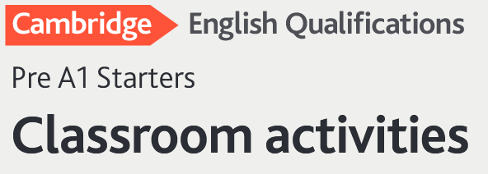

- https://www.teach-this.com/general-activities-worksheets/likes-dislikes
- https://www.britishcouncil.es/sites/default/files/warmers_and_fillers_booklet.pdf

- Watch this video on CLT
https://www.youtube.com/watch?v=XYdUB_e8_Zc

