5. Constructivism
Introduction
constructivism is developed on the foundations of cognitive psychology, which addresses how learning and cognition take place. It suggests that learning is more effective when a student is actively engaged in the learning process rather than attempting to receive knowledge passively.
Constructivism is built on the principle of active learning
It argues that learners are not passive recipients of information.Rather they construct their own understanding by actively engaging with the material
This engagement involves questions, hypothesizing , and making connections to their own experience

- Constructivist theory
Constructivism is based in part on the work of Jean Piaget and Lev Vygotsky, as well as a number of researchers.
According to Jean Piaget( 1951) , children take an active role in the learning process : they make observations, and learn about the world. As they interact with the world around them, they continually add new knowledge and build upon existing knowledge.
Jean Piaget’s theory of cognitive development suggests that children move through four different stages of intellectual development

HANDOUT
Jean Piaget identified the following development stages in children as they progress from birth to adolescence. 1) Sensorimotor stage (from birth to 2 years old): the child learns to interact with the environment by manipulating objects. This stage is characterized by the child’s vocabulary.2) Pre-operational stage (from 2 years to 7 years of age): Children start developing linguistic competence and by the age of 7, the child’s acquisition of the grammatical system is almost complete. 3) The concrete operational stage (from 7 to 11 years); intellectually, the child begins developing the ability to separate the self from the environment and to think logically. 4) Formal-operational stage (age of 12 onward): abstract thinking develops. The child now is able to make generalizations beyond his immediate context. He can understand division and fractions without having to actually divide things up, and solve hypothetical (imaginary) problems.

According to Vygotsky (1896-1934), social interaction plays a fundamental role in the development of cognition. This implies that a learner cannot create his/her knowledge without being influenced by the social context.
In this theory (social cultural theory), learning is not an isolated process.
It is something that occurs in a social context through the interaction with peers, teachers, or others in the environment

Zone of Proximal Development
The idea of the ZPD Lev Vygotsky in the early 1900s. Vygotsky believed that every person has two stages of skill development:
- a level they can achieve by themselves
- a level they can achieve with the help of an experienced mentor or teacher
The core idea of the ZPD is that a more knowledgeable person can enhance a student’s learning by guiding them through a task slightly above their ability level.
As the student becomes more competent, the expert gradually stops helping until the student can perform the skill by themselves.
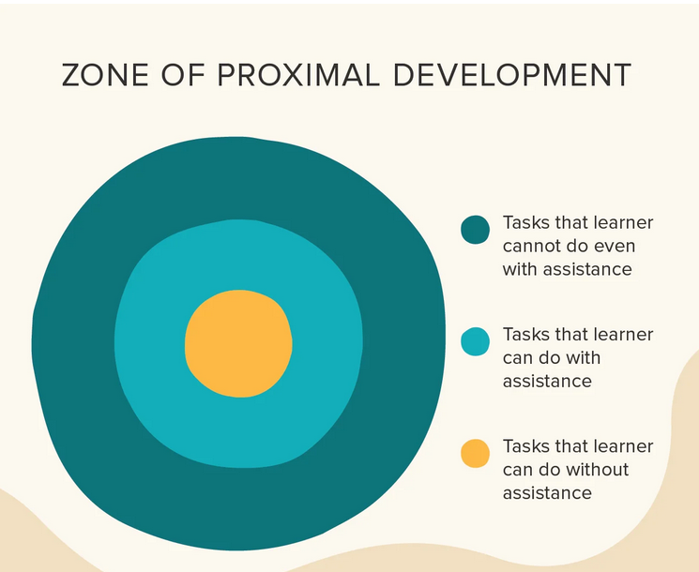
Constructivism focuses on learner-centredness
This means that Learning activities should be relevant, meaningful and engaging for each individual students
teachers should be facilitators, guiding learners to contruct their own knowledge, rather than acting as the primary source of information
HAND OUT
Even though constructivism is considered to be a branch of cognitivism (both conceive of learning as a mental activity), it distinguishes itself from traditional cognitive theories in a number of ways:
- Learners do not transfer knowledge from the external world into their memories; rather they build personal interpretations of the world based on individual experiences and interactions.
- In constructivism, the focus of teaching is on the empowerment of the learner. The teacher’s role is to engage learners in the discovery of knowledge and provide them with opportunities to reflect real-world situations of knowledge.
- Learning is something done by the learner, not something that is imposed on him.
- Learners construct their knowledge through their interaction with the physical world, collaboratively in social settings and in a cultural and linguistic environment.
- Principles of constructivism:
According to Vrasidas (2000) the basic and most important assumption of constructivism is that knowledge does not exist independent of the learner. Therefore, the core idea of constructivism considers learning as meaning making, and the negotiation of meaning. It is within this perspective that teachers should be aware of several key principles associated with constructivist learning theory. These include:
- Learning is constructed. This is the basic principle, meaning that knowledge is built upon other knowledge: Learners bring unique prior knowledge, experience, and beliefs to a learning situation.
- Learning is an active process. Learning involves sensory input to construct meaning. The learner needs to do something in order to learn, it’s not a passive activity. One of the common threads of constructivism is the idea that development of understanding requires the learner actively engage in meaning-making. In contrast to behaviourism, constructivists argue that "knowledge is not passively received but built up by the cognizing subject" (Von Glasersfeld, 1995).
- Learning is reflective: Teachers should encourage critical thinking by asking thoughtful, open-ended questions and ask the students to reflect on them and talk about their learning activities.
- Learning is collaborative: Teachers should encourage students to share their ideas and learn from each other.
- Learning is a social activity. It is directly associated to our connection with other people. Our teachers, our family, or peers, and our acquaintances impact our learning.
- Learning is contextual. Students don’t learn isolated facts and theories separate from the rest of our lives, we learn in ways connected to things we already know.

Conclusion
In the constructivist classroom, students interact with the environment and create their own interpretation of the world instead of being mere recipients of information transmitted by the teacher. Through constructivism, the learner is able to construct new knowledge through multiple representation, active engagement, collaboration and inquiry with the teacher acting as facilitator.
Learning is based on the active participation of learners in problem-solving and critical thinking given real and authentic problems.
- . 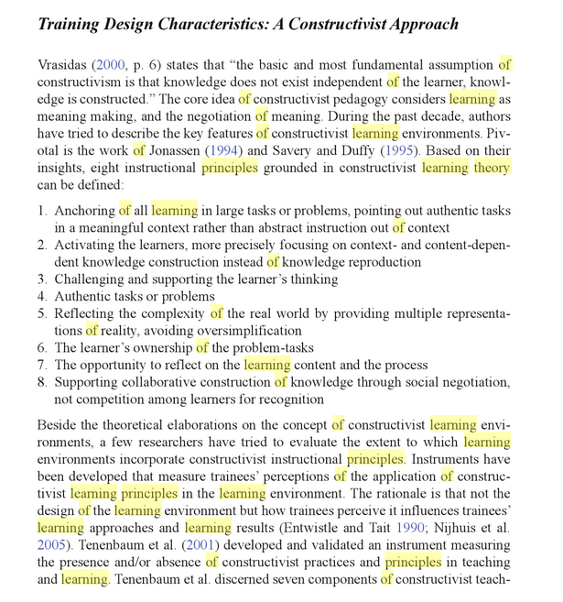
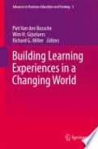 | 0 AvisRédiger un commentaire

Building Learning Experiences in a Changing World
publié par Piet Van den Bossche, Wim H. Gijselaers, Richard G. Milter

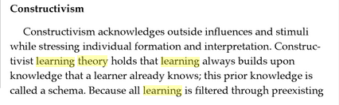
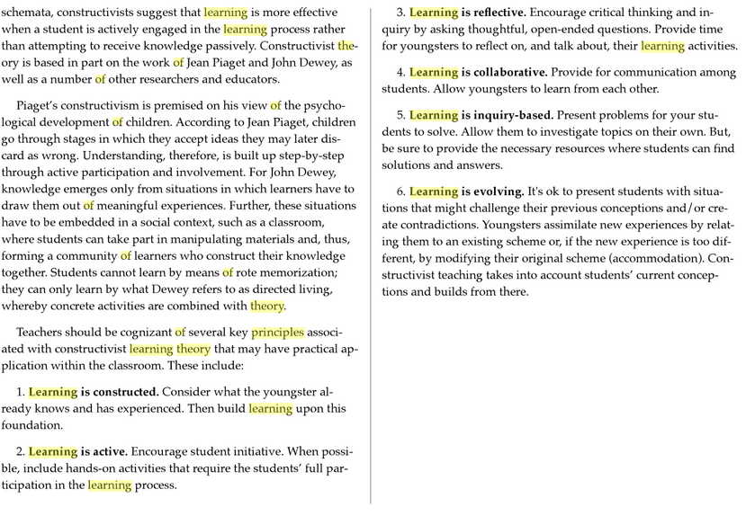
0 AvisRédiger un commentaire

Selling Skills for Teachers: Complete Teacher Program
De Robert Swerdlow

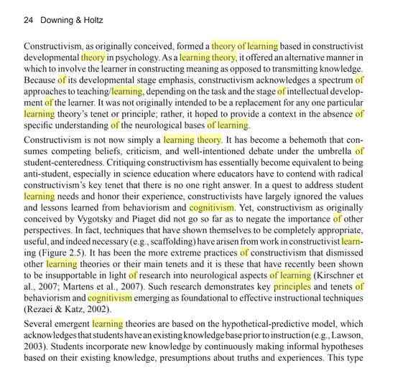

Online Science Learning: Best Practices and Technologies: Best Practices and ...
publié par Downing, Kevin, Holtz, Jennifer

