1. Fundamentals concepts in language teaching and learning
I. Didactics
“Didactics” is often referred to as the science of the art of teaching within a specific field. Didactics is based on multiple theories of teaching, and in a wider sense, theory and the practical application of teaching and learning methods.
II. Pedagogy
Pedagogy is a way of teaching and learning. It is defined as “the instructional techniques and strategies that allow learning to take place. It refers to the interactive process between teacher and learner and it is also applied to include the provision of some aspects of the learning environment (including the concrete learning environment, and the actions of the family and community)(Gilden & Bell, 2002, p.10). Pedagogy specifies the best learning conditions that enhance comfortable acquisition of learning targets.
III. What is the difference between didactics and pedagogy?
While didactics is a discipline that is essentially concerned with the science of teaching and instruction for any given field of study, pedagogy is focused more specifically on the strategies, methods and various techniques associated with teaching and instruction. Pedagogy also refers to the ability of a teacher to match theoretical foundations or concepts with practical methods of knowledge transfer in education on language-related problems, while responding and adapting to the learning strategies of their students. Finally, didactics is teacher- centered and based on the sum of theoretical knowledge and practical experience. In comparison, pedagogy is learner-centered, since the teaching must be adapted to respond to the complexity of student needs.
- Didactic triangle
Traditionally, the context of teaching is reduced to the dual relation between the teacher and the learner. However, some researchers have come to stress another component of the classroom, namely content. Houssaye (1988) depicts the didactic relations of the classroom in the didactic triangle. This latter is composed of the three major elements of the classroom (i.e., content, teacher, and learner).
- Content refers to knowledge that is to be transmitted, be it information, skills, or attitudes.
- The teacher is the knower who presents knowledge directly or indirectly. Besides, the teacher should show the intention to teach.
- The learner is the recipient of the beneficiary of knowledge. He should also show the intention to learn.
Additionally, the triangle highlights the three possible didactic relations of teacher-content, teacher-learner and learner content. The relation of teacher-content refers to the process of teaching, the relation teacher-learner designates training, and finally the relations learner-content denotes the process of learning.

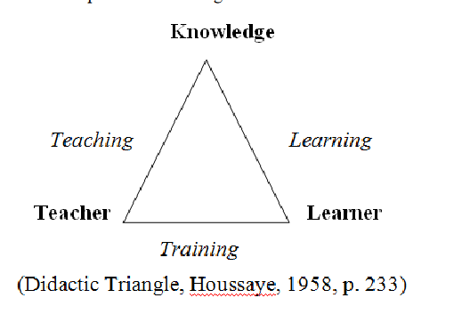

This representation of a teaching act shows that there are only three possible relations in the classroom.
- The relationship teacher-knowledge
In this case, the teacher has the role of structuring knowledge, organizing and presenting it according to the types of knowledge he/she thinks are important or relevant.
- The relationship teacher-learner
In this case, the teacher establishes a warm relationship with his learners and uses mainly indirect or inductive methods of teaching.
- The relationship student- knowledge
This relationship represents students assuming the responsibility of their learning. They nominate topics, negotiate learning targets, do tasks and assess themselves.

- Terms related to didactics
- Method, approach, technique
Approach: theories about the nature of language and the nature of language Learning Method: it is concerned with the practical realization of an approach. Technique: it is a specific strategy that teachers use in the classroom.
- Instructional materials
They are all the tools used in educational lessons.
Any resource a teacher uses to help him teach his students
There are 4 types of instructional materials
- Textual Materials: These are instructional materials that use words, either printed or spoken, to communicate information and instructions. ...
- Visual Materials: ...
- Audio Materials: ...
- Interactive Media:

- Activities , tasks
Learning activities and exercises are tasks that the teacher presents orally or in writing to the learner. The nature of activities has changed throughout the history of foreign language teaching methods. For example, traditional methods such as GMT used repetition, translation, and rote learning while more recent activities are more geared towards the use of authentic real-life activities such as discussions and problem-solving situations ( Brown, 12 2006).

- Acquisition versus learning
Acquisition is a natural process that involves the use of language in communicative settings, while learning is a more staged process that involves 'knowing about language. Acquisition occurs as we interact with others due to our need to communicate, while learning involves a more conscious manipulation of language elements, for example, in a classroom setting. Acquisition is more subconscious. informal, and based on feeling and depends on the openness or ATTITUDE of the person; learning is explicit and conscious, formal, and based on rules and depends on aptitude .
