Texte 05

Corn, (Zea mays), also called Indian corn or maize, cereal plant of the grass family (Poaceae) and its edible grain. The domesticated crop originated in the Americas and is one of the most widely distributed of the world’s food crops. Corn is used as livestock feed, as human food, as biofuel, and as raw material in industry.
The corn plant is a tall annual grass with an erect, solid stem. The narrow leaves have wavy margins and are spaced alternately on opposite sides of the stem. Staminate (male) flowers are borne on the tassel terminating the main axis of the stem. The pistillate (female) inflorescences, which mature to become the edible ears, are spikes with a thickened axis, bearing paired spikelets in longitudinal rows; each row of paired spikelets normally produces two rows of grain. Varieties of yellow and white corn are the most popular as food, though there are varieties with red, blue, pink, and black kernels, often banded, spotted, or striped. Each ear is enclosed by modified leaves called shucks or husks. Many industrial varieties of corn are genetically modified for resistance to the herbicide glyphosate or to produce proteins from Bacillus thuringiensis (Bt) to kill specific insect pests. In addition, some strains have been genetically engineered for greater drought tolerance.
Corn, or maize, a cereal cultivated in most warm areas of the world, has many varieties. The United States, the principal producer of corn, cultivates two main commercial types, Zea indurata (flint corn) and Z. indentata (dent corn). The plant grows to a height of about three metres or more. The corn kernel is large for a cereal, with a high embryo content, and corn oil extracted from the germ is commercially valuable.
Much of the corn is wet-processed to produce corn flour, widely used in cooking.
Corn is also used to produce ethanol (ethyl alcohol), a first-generation liquid biofuel. In the United States corn ethanol is typically blended with gasoline to produce “gasohol,” an automotive fuel that is 10 percent ethanol. From www.britannica.com
- Read the text then answer the questions below:
- The corn is
- an annual plant like the wheat plant.
- a very big tree.
- Edible grain means
- for a livestock feed.
- a grain that we can eat.
- The corn has
- big and very large leaves.
- close (restricted ) leaves.
- We can find
- a just yellow and white corn.
- yellow, white, red, blue, pink and black corn.
- The corn is genetically modified for dry season resistance.
- True.
- False.
- The corn’s main products are:
.....................................................
.......................................................
........................................................
- The corn’s derived alcohol is used as an alternative fuel for the vehicles.
- True.
- False.
- Give a definition to the underlined words.
...................................................................................

..................................................................................
...................................................................................

- Complete legends. (a plant and its kernel)
…………………….
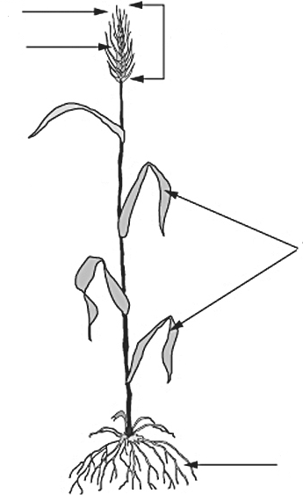 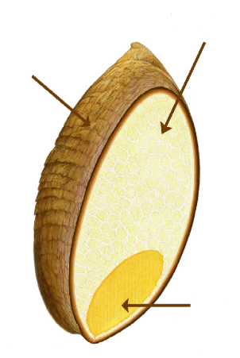1......................................................... 2.......................................
…………………….
…………………….
…………………….
…………………….
…………………….
…………………….
…………………….

