Budgeting
The tactical implementation of a business plan
Written by CFI Team
Updated January 30, 2022

What is Budgeting?
Budgeting is the tactical implementation of a business plan. To achieve the goals in a business’s strategic plan, we need a detailed descriptive roadmap of the business plan that sets measures and indicators of performance. We can then make changes along the way to ensure that we arrive at the desired goals.
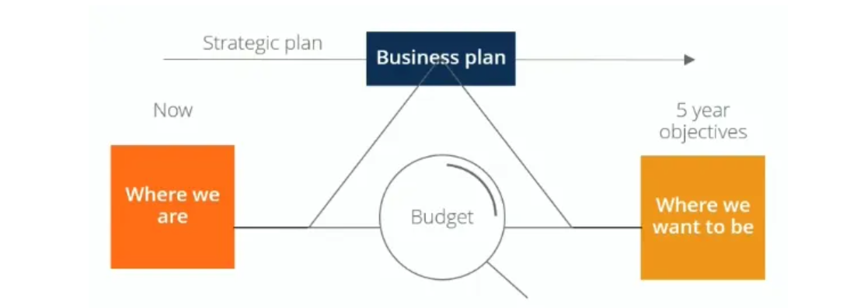

Translating Strategy into Targets and Budgets
There are four dimensions to consider when translating high-level strategy, such as mission, vision, and goals, into budgets.
Objectives are basically your goals, e.g., increasing the amount each customer spends at your retail store.
Then, you develop one or more strategies to achieve your goals. The company can increase customer spending by expanding product offerings, sourcing new suppliers, promotion, etc.
You need to track and evaluate the effectiveness of the strategies, using relevant measures. For example, you can measure the average weekly spending per customer and average price changes as inputs.
Finally, you should set targets that you would like to reach by the end of a certain period. The targets should be quantifiable and time-based, such as an increase in the volume of sales or an increase in the number of products sold by a certain time.
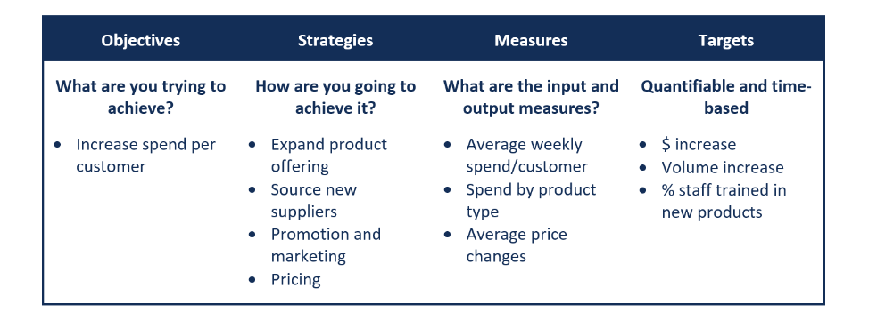

Goals of the Budgeting Process
Budgeting is a critical process for any business in several ways.
1. Aids in the planning of actual operations
The process gets managers to consider how conditions may change and what steps they need to take, while also allowing managers to understand how to address problems when they arise.
2. Coordinates the activities of the organization
Budgeting encourages managers to build relationships with the other parts of the operation and understand how the various departments and teams interact with each other and how they all support the overall organization.
3. Communicating plans to various managers
Communicating plans to managers is an important social aspect of the process, which ensures that everyone gets a clear understanding of how they support the organization. It encourages communication of individual goals, plans, and initiatives, which all roll up together to support the growth of the business. It also ensures appropriate individuals are made accountable for implementing the budget.
4. Motivates managers to strive to achieve the budget goals
Budgeting gets managers to focus on participation in the budget process. It provides a challenge or target for individuals and managers by linking their compensation and performance relative to the budget.
5. Control activities
Managers can compare actual spending with the budget to control financial activities.
6. Evaluate the performance of managers
Budgeting provides a means of informing managers of how well they are performing in meeting targets they have set.

Types of Budgets
A robust budget framework is built around a master budget consisting of operating budgets, capital expenditure budgets, and cash budgets. The combined budgets generate a budgeted income statement, balance sheet, and cash flow statement.
1. Operating budget
Revenues and associated expenses in day-to-day operations are budgeted in detail and are divided into major categories such as revenues, salaries, benefits, and non-salary expenses.
2. Capital budget
Capital budgets are typically requests for purchases of large assets such as property, equipment, or IT systems that create major demands on an organization’s cash flow. The purposes of capital budgets are to allocate funds, control risks in decision-making, and set priorities.
3. Cash budget
Cash budgets tie the other two budgets together and take into account the timing of payments and the timing of receipt of cash from revenues. Cash budgets help management track and manage the company’s cash flow effectively by assessing whether additional capital is required, whether the company needs to raise money, or if there is excess capital.
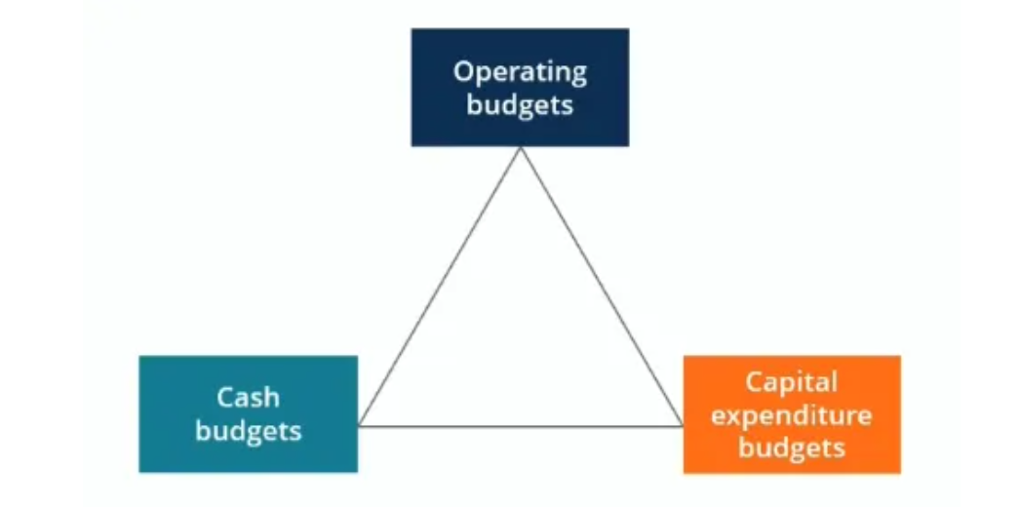

The Process
The budgeting process for most large companies usually begins four to six months before the start of the financial year, while some may take an entire fiscal year to complete. Most organizations set budgets and undertake variance analysis on a monthly basis.
Starting from the initial planning stage, the company goes through a series of stages to finally implement the budget. Common processes include communication within executive management, establishing objectives and targets, developing a detailed budget, compilation and revision of budget model, budget committee review, and approval.

CFI is a leading provider of online financial certification programs, training, and workforce development

