Overview of Budgeting Career
Article written by: Jeff Schmidt VP of Financial modelling
https://corporatefinanceinstitute.com/resources/fpa/budgeting/
Budgeting is a strategic implementation of the business plan of a company or a project to achieve the desired goals and objectives. Budgeting
also means forecasting the future of the company by creating appropriate budgets to take care of the financial needs in the long term. Budgeting is important because of the following reasons :
- Aids in planning and crisis management, i.e., it allows the company management to take appropriate actions when a crisis arises.
- Encourages building a long-lasting relationship with other departments since the budgeting manager needs to take the help and inputs from the other departments to complete the budget.
- It helps in having a clear understanding amongst the employees in the organization as they are made aware of the budgetary allocations in the next financial year. Also, this process helps in creating synergies with other departments like Operations, Accounts, Credit, Investments, and HR.
- Motivates the sales teams to achieve their targets and goals.
- It helps control the company’s financial position by analyzing the expected and actual budget variances.
- It is a vehicle to measure the performance of the employees.
Let us now look at the top 4 budgeting career options in detail

Career #1 – Financial Planning & Analysis
Financial Planning & Analysis takes care of the company’s budgets in the FP&A department. Every company has its FP&A department to take care of the financial projections and periodically prepare a business plan to showcase the future roadmap.
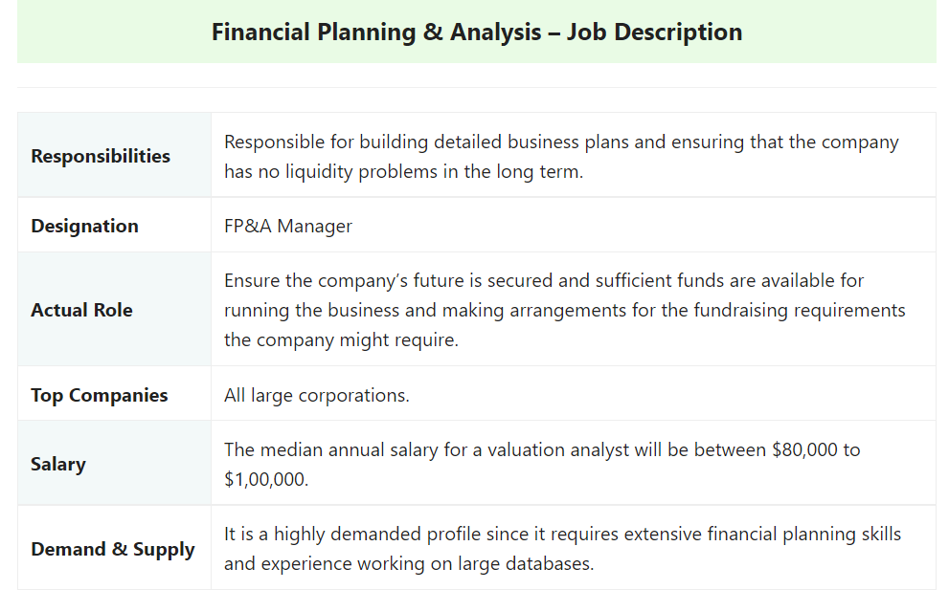

Career #2 – Financial Analyst
A financial analyst is a professional who analyses the company’s financial position.
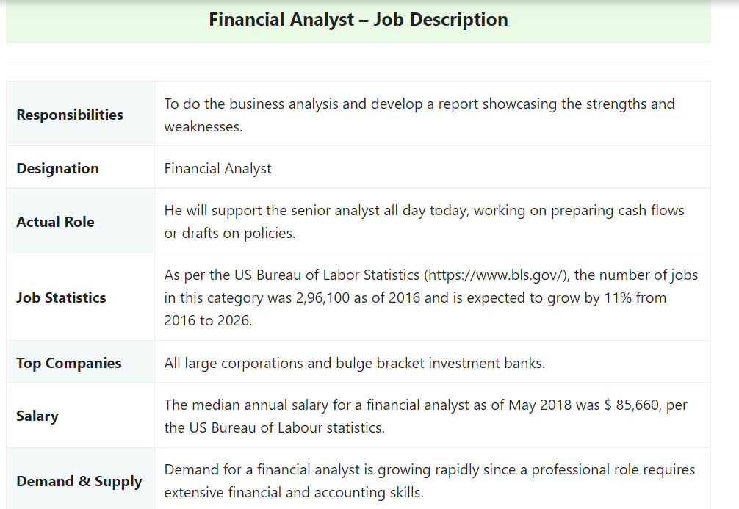

Career #3 – Budget Analyst
Budget Analyst advises companies on how to prepare financial budgets and how to organize their finances.
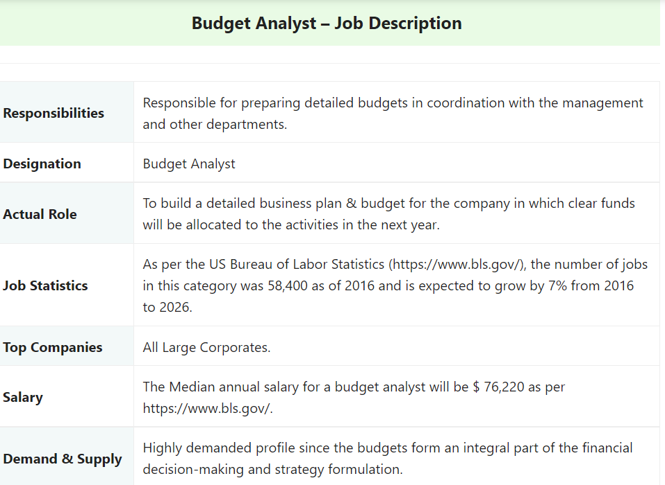

Career #4 – Management Accountant
Management Accountant works very closely with the management and the budgeting manager.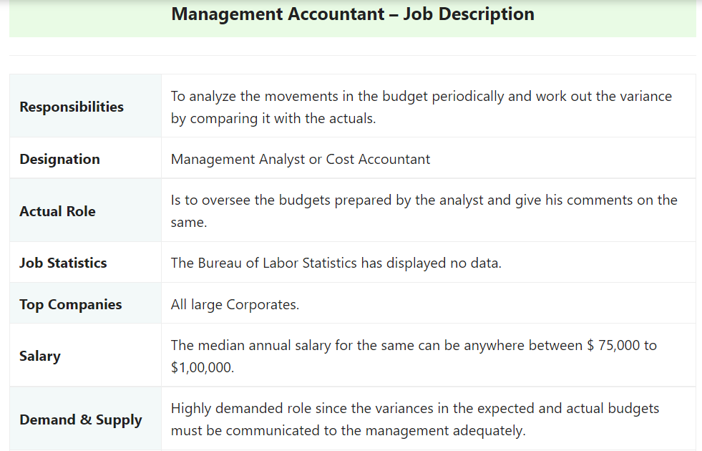

Conclusion
Budgeting is one of the most crucial roles in any organization as it lays down the path or the road map for the company to plan its strategic decisions.

